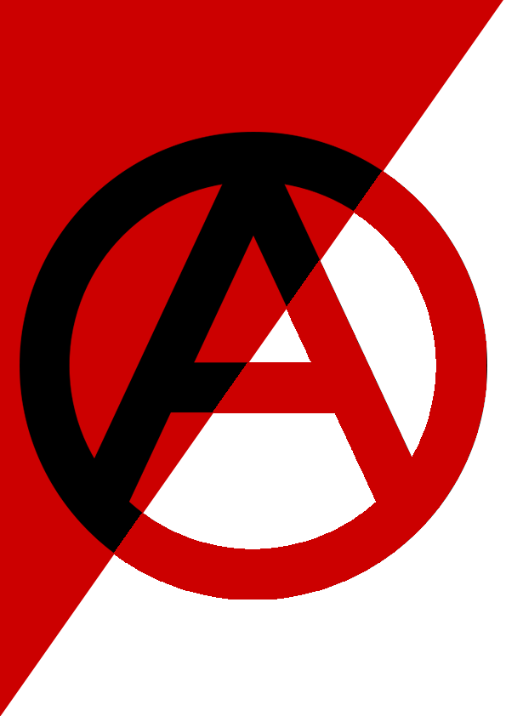
Solidarity Protest
MEET: Spanish Consulate, 63 North Castle St, Edinburgh EH2 3LJ
FRIDAY 6 March 2015 – FROM 12:00noon

13 PEOPLE FACING TRIAL JUST FOR BEING ANARCHISTS
On 16/12/14 the Catalan police broke into 14 houses and social centres, destroying and stealing everything of value. 11 comrades were charged by a high court and 7 spent more than a month in prison.
On 29/01/15, the 7 imprisoned comrades were released but the state accuses all 11 (plus the 2 anarchists locked up for more than a year) of being members of a terrorist group, thus reaffirming its intention to treat everyone who questions it as a terrorist.

Addresses of the imprisoned comrades:
Mónica Andrea Caballero Sepúlveda - Ávila-Prisión Provincial,
Ctra. de Vicolozano s/n Apdo. 206. 05194 Brieva, Ávila, España
Francisco Javier Solar Domínguez - C.P. de Villabona Finca Tabladiello.
33480 Villabona-Llanera, Asturias, España
today they want to destroy anarchism, but above all they want to destroy freedom
REPRESSION FALLS ON THOSE WHO STRUGGLE
SO IT ALSO FALLS ON US TO BUILD SOLIDARITY
efectopandora.wordpress.com | ES68 3025 0001 19 1433523907 (CAIXA D'ENGINYERS)
drop the charges!

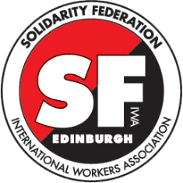 | Edinburgh Solidarity Federation, c/o ACE, 17 West Montgomery Place,  Edinburgh EH5 7HA | edinburghsf@riseup.net | www.solfed.org.uk  International Workers’ Association, Targowa 22 lokal 27 a03-731  Warszawa, POLSKA | secretariado@iwa-ait.org | www.iwa-ait.org  further information: efectopandora.wordpress.com

